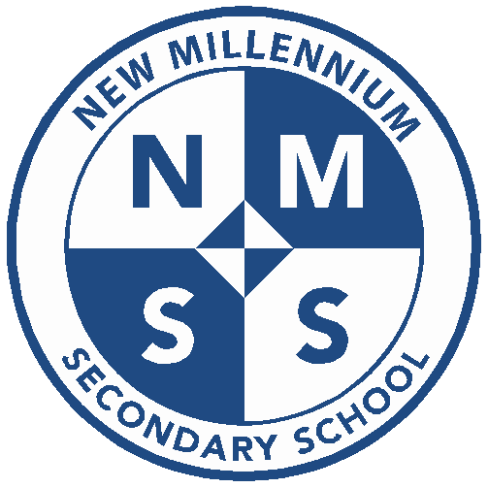
Staff Email List 2022-2023
Samantha Navarro (Principal): snavarro@newmillenniumschool.org
Nichole Sims (COO): nsims@newmillenniumschool.org
Alex Carrethers (Administration Assistant) acarrethers@newmillenniumschool.org
Karen Lozano (Admissions/Enrollment/Attendance) klozano@newmillenniumschool.org
Kyle Kirtz (Counselor) kkirtz@newmillenniumschool.org
Alejandro Flores (Math Teacher) aflores@newmillenniumschool.org
Nathaniel Catbagan (Art Teacher): ncatbagan@newmillenniumschool.org
Alexandria Gonzales (Resource/Coordinator Teacher) agonzales@newmillenniumschool.org
Lakisha Lewis (Math Teacher): llewis@newmillenniumschool.org
Kyle Lentz (Social Studies Teacher): klentz@newmillenniumschool.org
Amber Myers (English Teacher): amyers@newmillenniumschool.org
Lewis Nelson (Physical Education Teacher): lnelson@newmillenniumschool.org
Lonnita Russell (Science Teacher): lrussell@newmillenniumschool.org
Stephanie Shatkina (English Teacher): sshatkina@newmillenniumschool.org
Conner Petterson (Social Studies Teacher): cpetterson@newmillenniumschool.org
Alison Peet (Spanish Teacher) apeet@newmillenniumschool.org
Brandon Sampson (Campus Supervisor) brsampson@newmillenniumschool.org
Demika Daniels (Campus Supervisor) ddaniels@newmillenniumschool.org
Sandy Herrera (Front Office) sherrera@newmillenniumschool.org

